Name________________________________Period_________ Date________

Plant Propagation
Asexual Plant Reproduction- Layering
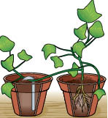
Ground Layering
- Often done with ________________ plants
- Take section of vine and place ___________________ soil
- In time, new roots form

Air Layering Steps

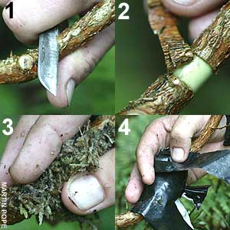
- 1 & 2:
- 3:
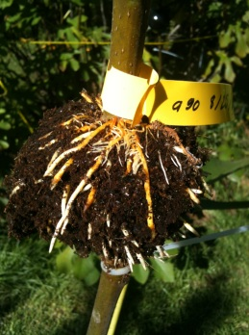
- 4:
- Result =

Other types of layering:
