Name ________________________________________________ Date___________________

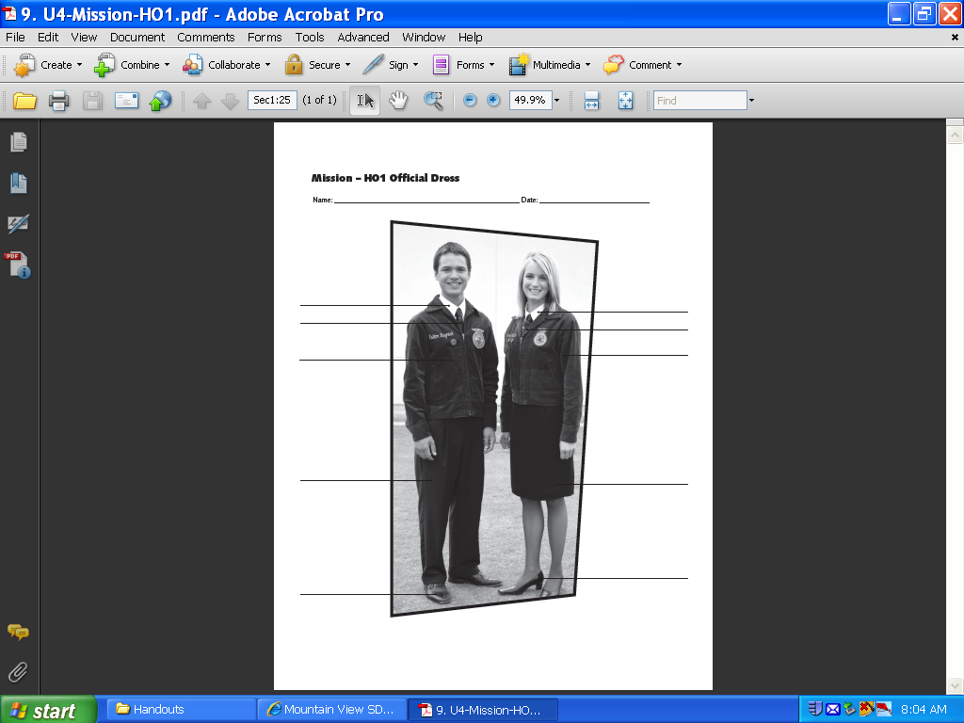FFA Basics

Label the Official Dress

Write the FFA Mission in GREEN

Write the FFA Motto in BLUE

Color and label the circles with the official FFA colors

Who wrote the FFA Creed?

Write the four levels of FFA membership in PUPLE

Write the name of the official FFA Magazine in ORANGE

LABEL and DEFINE the parts of the FFA Emblem Red







