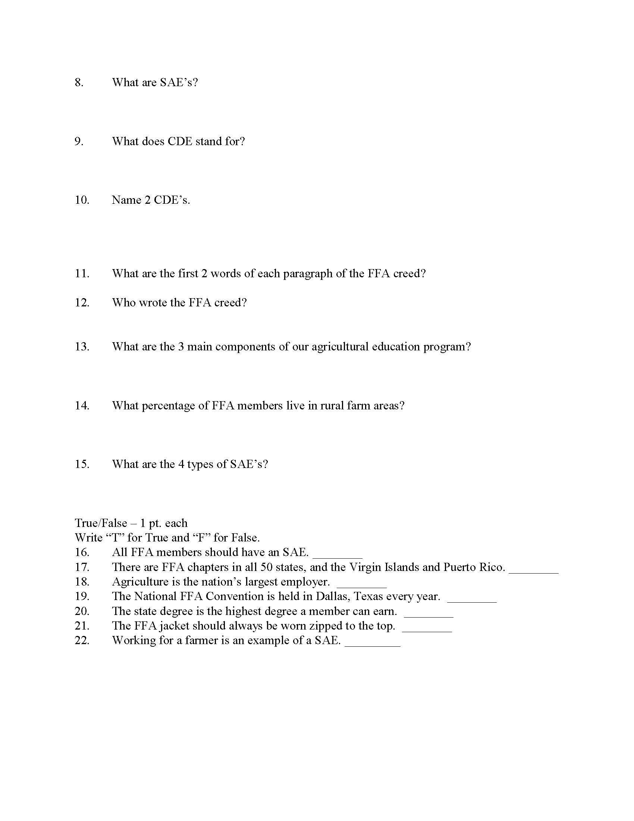
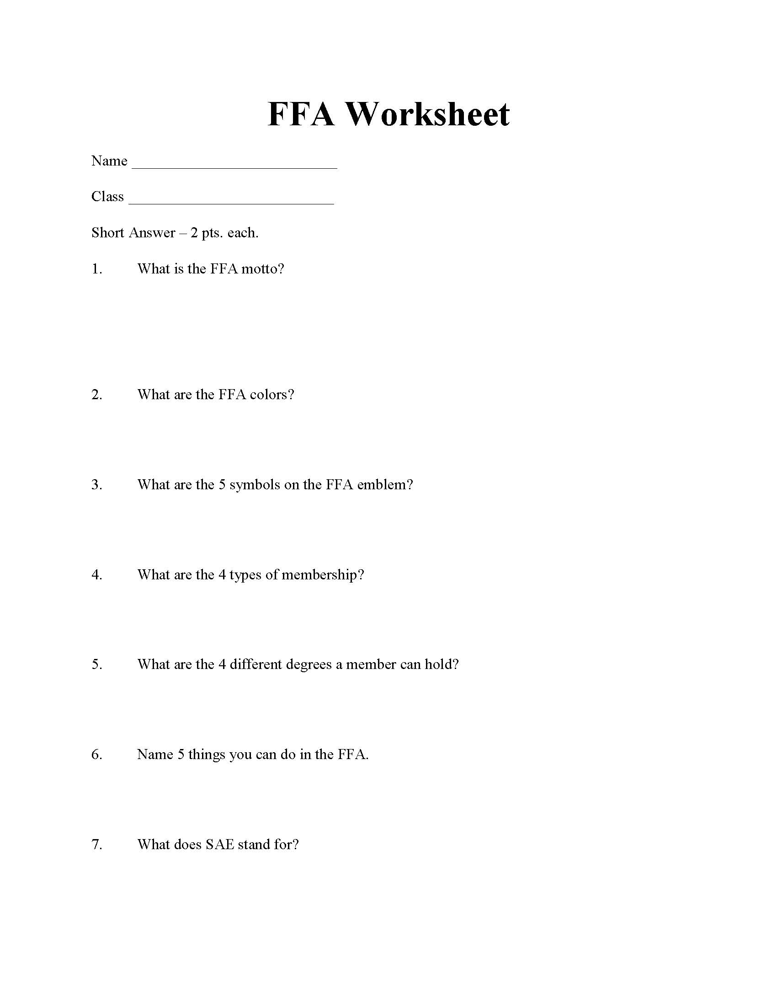Name ________________________________________________ Date___________________
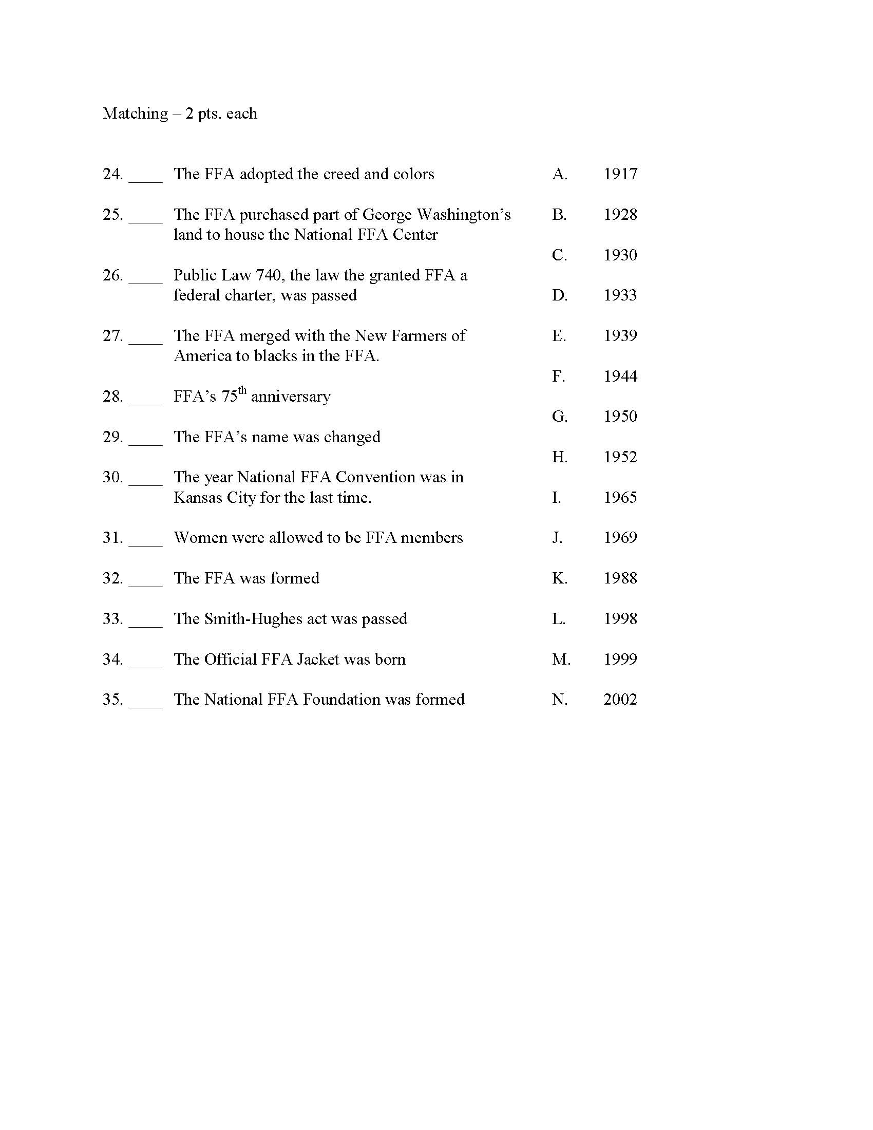
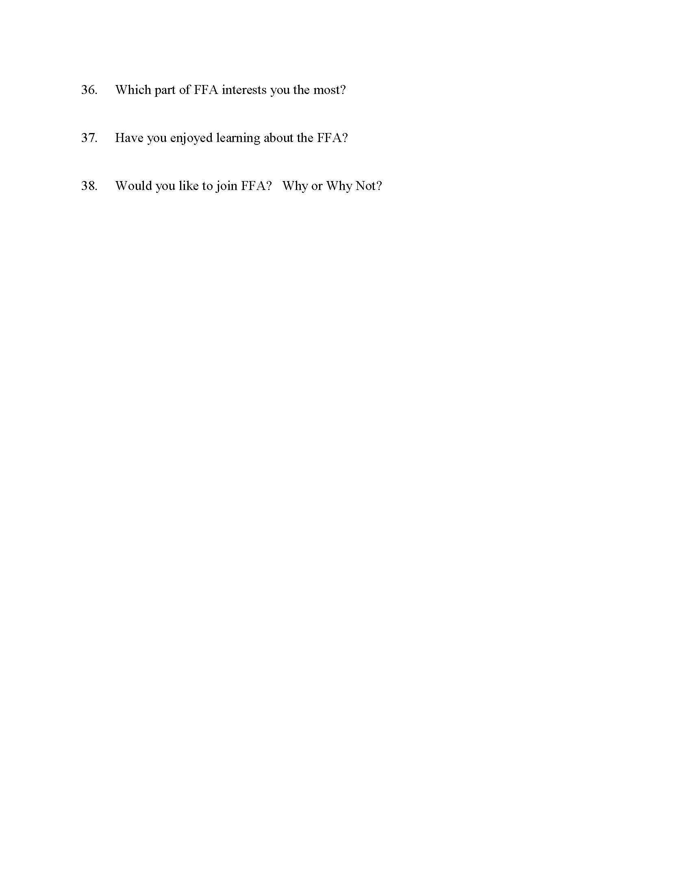
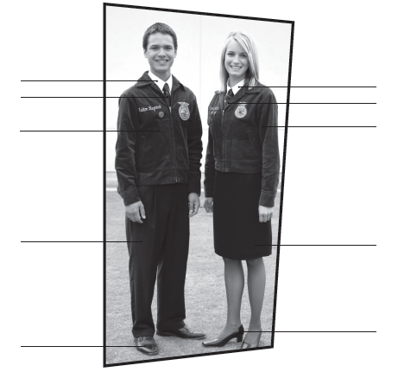
FFA Basics
Write the FFA Motto in BLUE
Label the Official Dress
Write the FFA Mission in GREEN

Color and label the circles with the official FFA colors

Who wrote the FFA Creed?

Write the name of the official FFA Magazine in ORANGE
Write the four levels of FFA membership in PUPLE

LABEL and DEFINE the parts of the FFA Emblem Red












Part A. Write the correct word that belongs in each circle in the FFA’s three-circle model.
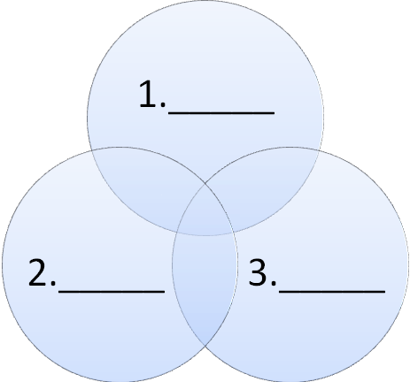

Part B. Answer the following questions in complete sentences.
4. Describe one unique feature about the agricultural education classroom.
__________________________________________________________________________________________________________________________________________________________________________
5. Identify one eligibility requirement for joining the FFA.
_________________________________________________________________________________________________________________________________________________________________________
6. What do the letters SAE represent?
_________________________________________________________________________________________________________________________________________________________________________

