C:\Users\Hailey Mae\AppData\Local\Microsoft\Windows\Temporary Internet Files\Content.IE5\WE78B2L0\MC900353890[1].wmf

**Name:_________________________**

D______________ W________________ V___________ Systems (DWV)

1. What two systems make up plumbing?

_____________________ - Takes Fresh water in

_____________________ - Takes out used water and sewage waste

2. What connects the two systems?

3. What are two types of drain and vent systems?

_______________________

_______________________

4. Why are vents important in a plumbing system? (Answer is in the video)

Label the Drain – Waste – Vent System diagram. Use the following terms in the boxes:

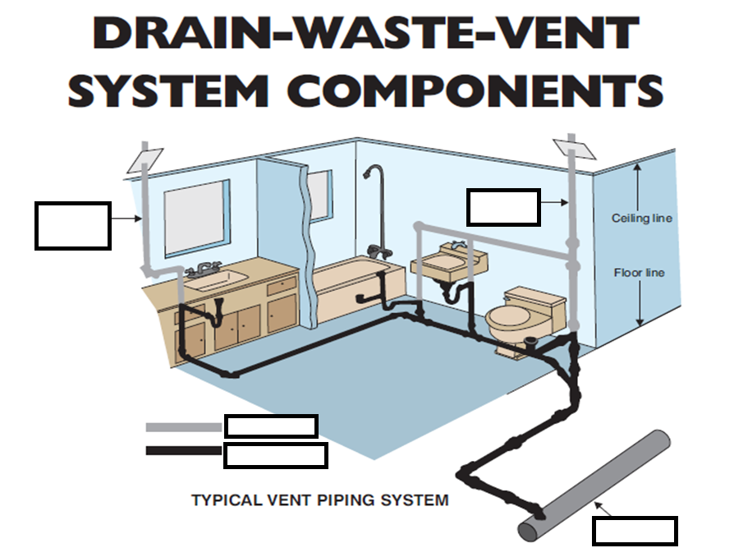

**1) Drain Waste Pipe**

**2) Main DMV Vent**

**3) Main Sewer**

**4) Venting Pipe**

**5) Waste Stack Vent**

5. Draw a septic tank below. Label it with the following terms **and** draw the bacteria.

**Intake from house Outlet to drain field Scum Liquid Sewage Sludge**

6. What is the purpose of the drain field?

* 1. allows liquid sewage to escape the septic tank
  2. helps get the waste out of the house
  3. holding tank for sludge and bacteria
  4. so the bacteria can work better

7. Why is it important to get your septic tank drained every three to five years?

8. Label this diagram using the following words. (Draw arrow if necessary)

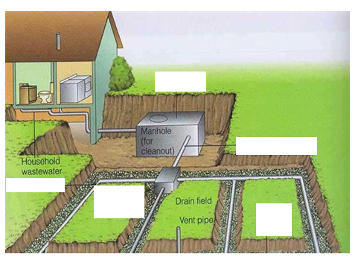**Distribution Box Gravel or Crushed Rock Non-Perforated Pipe Perforated Pipe’ Septic Tank**