Course: Agricultural Communications

Unit: (Standard 4) Students will develop photography, layout and design skills to create print media.

Unit Objectives:
- Design and develop a computer-generated layout for print media.
- Digitally photograph subjects for a news story or feature article.
- Select and edit photos for a news story or feature article.
- Write an appropriate headline and photo captions for a news story or feature article.
- Write and design the layout of a news story with photos for an agricultural newspaper.
- Write and design the layout of a feature article with photos for an agricultural magazine.
- Design and layout a brochure.

Materials Needed (Equipment):
- Adobe Creative Suite C3, C4, C5 or C6 (Photoshop, InDesign, and Adobe X Pro)
- Computers and Internet
- Microsoft Works (Word, Excel, Publisher)
- Camera with memory card
- Projector
- Paper
- Media Photo Folder
- Graphic Design Labs & Job Sheets
- Tricks and Tips Folder on InDesign, Photoshop, and Publisher

Facilities: Classroom and Computer Lab

Interest Approach:
Interest Approach #1:
Hand out some old magazines or news article. Have them write down 10 to 15 things they like about the layout. Have them then discuss it with their neighbor. After, open it up for class discussion, where you can then introduce the parts or components to creating a newsletter or brochure–photos and document design.
Interest Approach #2
Show the class 10-15 photos that you have compiled that are good and bad quality. You can find photographs that are pixilated, busy, not balanced, not using the rule of thirds, etc.... Have them write down their thoughts and then discuss with a class member. After, open it up for class discussion, where you can then introduce the parts or components to creating a newsletter or brochure–photos and document design.
Interest Approach #3
Before you begin teaching these units, you could have a guest speaker come and talk about newspaper, magazine and other print media writing. This will interest the students in learning more about news writing and document design.
The following are good contacts:
Matt Hargreaves, VP of Communications & Farm Bureau News Editor
801-233-3008
matt.hargreaves@fgfs.com
______________________________________________________________________________

Rachel Hodson & David Vogel- Editors and Owners
810-742-1592
info@ediblewasatch.com

Objective A: Design and develop a computer-generated layout for print media.

Curriculum (Content)  (What to teach) | Instruction (Methodology)  (How to teach)
DESIGN A LAYOUT FOR PRINT MEDIA  Print media can feel overwhelming, especially if you have little or no knowledge about document design. This objective to get the class started in designing a layout using multi-media software. InDesign and Publisher are the two you can use.  To master this objective, open the “Graphics Design Labs” in the labs folder. Also in the “supplemental folder is a newsletter–publisher, which is a layout example in publisher. The files that say April-May and March-April are example magazine layouts, created in InDesign.  Located in the “Graphic Design Lab” folder, there are multiple folders of agriculture-related topics.  Open the folder to find the lab sheet, graphics, logo, Article InDesign page layout, and an example newsletter InDesign.  Follow the Graphic Design Instruction file to begin the process.  If you are new to InDesign, please read the tips and tricks as well as Introduction to InDesign lessons and PowerPoint.  To help with the layout, have the students look at other magazines or newsletters. This is always the best method of learning.  To begin teaching this concept, the article is not necessary. They can use filler text.  It would be better, when they grasp more of the content and skill to read and write a story based on the articles. | Lesson: InDesign Tip and Tricks  Lesson: InDesign Manual  Lesson: Introduction to InDesign  Lesson: Intro to Adobe InDesign  Lesson: Indesignintro  Lesson: Introduction to Publisher  Supplemental:  - InDesign Shortcuts  - Newsletter – Word  - Newsletter - Pub  - April-May Newsletter  - Sample Graphic Design  - March-April Magazine  To better understand, read the lessons listed above on InDesign. The lessons are basic tips and tricks as well as systematic instruction on all the tools and techniques.  List of Folders:  Graphics Design  - Ag Ed  - Bees  - Commodities  - Farm Bill  - Farmers Market  - Utah Deaf and Blind – FFA  - Utah Lake  - Water Shortage  - Graphic (InDesign pages)  - Graphic Design Instruction (lab)  - Sample graphic  - USDB Sample Graphic  In each topic folder  Article  Graphics  Logo  Graphic  Graphic Design Instruction (lab)  YOU WILL NEED TO DOWNLOAD ALL FOLDERS AND SHARE WITH CLASS, SO THEY CAN ACCESS THE FILES.

Activity:
- Graphic Design Labs

Objective B: Digitally photograph subjects for a news story or feature article.

Curriculum (Content)  (What to teach) | Instruction (Methodology)  (How to teach)
What makes a quality photograph or digital image?  What makes a photograph or graphic “eye catching” or “appealing?”  Digital Photography:  “A picture is worth a thousand words.”  Why do you think people use this in relations to photographs and digital images?  Seeing an image can be more exciting at times  than reading a news story.  Digital Photography Terms:  - Pixels - Resolution - Image Quality - JPG - TIFF - RAW - Light - Color - Portraits & Landscapes - Framing - Emphasis - Angle of View - Balance - Rule of Thirds - Close-Ups - Tone & Sharpness - Arrangement - Depth of Field - Background Distractions  Photos are a major part of agricultural communication. They are very valuable in telling the other side of the story that sometimes is hard to explain. It also makes connections with the story.  Photography is used in every type of marketing tool.  - Brochures  - Web page  - Email  - Press release  - Juried shows  - Spotlight a new product  Digital Photography:  - Digital photography has transformed the way news is edited and distributed.  - Managing the workflow or capturing, downloading, processing, and cataloging images is what separates great news from not so great news.  - The photo can tell a story as vivid, candid and descriptive as any painting.  - With editing software, one can become a true artist, constructing his or her message in every detail.  Photography: “Writing with Light”  Photographs and Graphics are editing for various reasons – to ensure quality.  Photos are taken for a different purpose.  - News Photograph:  - Simple, close up shots  - No far away shots  - Still use captions  - Feature Photograph:  - Not tied to a story  - Details what the article is about  - Captions are included to provide information on photo  Benefits of Digital Photography:  - You can take several photos and view them instantly  - They are easy to store  - You can print only the photos you want.  - More creative control  - Use computer and photo-editing software to touch up and enhance pictures  - Instant, easy, photo sharing  - E-mail  - Website  - Photo gallery  - Flickr  - Facebook  - Instagram  Digital Cameras:  When you take a snapshot of something with your camera, it stores the images in millions of tiny picture elements called PIXELS.  PIXELS – Know as “Picture Elements” align everything up and create a quality photo by using a single point of light.  Tips:  - Megapixels – Determine the total size (Dimensions) of the image recorded by camera  - More MP does not always mean a better picture  - Digital Image dimensions do not equal print dimensions  - I.e. A full quality image from an 8 megapixel camera will produce a digital image measuring approximately 9X14 inches, but printing standards say that you should not print to “Photo Quality” any larger than 8X10  - 1280 X 1024 is 1280 pixels times 1024 pixels or do the simple math, 1280X1024 = 1,314,560 pixels or 1.3 mega pixels.  - The more mega pixels in your camera, the bigger the picture, and better the print.  - Remember that pixel dimensions will vary by brand.  Pixels vs Print Size  Each colored box represents a certain number of megapixels. The numbers along the top and left side are print dimensions in inches at 300ppi (pixels per inch). Most books and magazines require 300ppi for photo quality. For example, the chart shows that you can make a 5" x 7" photo quality print from a 3 megapixel camera.  Chart  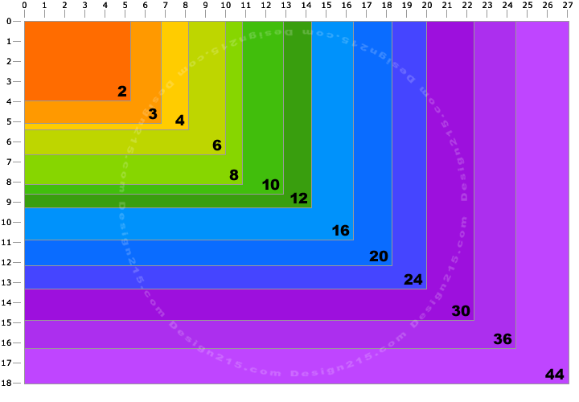  Resolutions:  - Following resolution settings for print and web.  - Web or Video – 72-100 ppi  - Black and White photos – 150 ppi  - Full-color photos – 300 ppi  Image Quality :  - Good, Better, and Best  - These settings reflect the compression levels of photos  - Compression refers to the amount of image your camera collects when taking a photo  - Lower Compression = Large File Size  - High Compression = Small File Size  Good – Lowest Acceptable Quality, Good for Online Usage, Prints 5x7 and 4x6  Better – Acceptable Picture Quality, Medium File Sizes, Prints 8x10 and Smaller  Best – Excellent Picture Quality, Large File Sizes, and Prints (11x17)  File Format:  After taking photos with a camera and then adjusting the colors, size, levels, brightness, exposure. You need to save it so that you can email or use it in your newsletter, brochure, flyer, etc…  Several formats have been developed for digital images.  Refers to the way the computer stores the data  More common formats include:  - JPEG  - TIFF  - RAW  - PDF  File Format:  - JPEG – Joint Photographic Experts Group  - Most Common Format  - Low Quality - Compressed File  - Ideal for Web and Email  - TIFF – Tagged Image File Format  - High Quality – Uncompressed File  - Capable of Editing  - Intended for Printing  - RAW  - Digital Negatives  - Not directly usable as an image, but has all of the information needed to create an image  Light with Digital Photography:  Light is the factor that makes quality pictures  Study the effects of light in your pictures  Use natural light for your advantage  - Varies season to season  - Best light is during mid-day and early afternoon.  - Varies based on position – front, back or to the side (left or right)  Avoid strong overhead light, which cast hard shadows.  When light is absent, use diffuser light between light sources and subject.  - Diffusers spread over large areas  Manipulate the scene to create the effect you want  - Move lights  - Move the subject  Purchase additional light  Digital Photography Key Points:  Portrait  Landscape  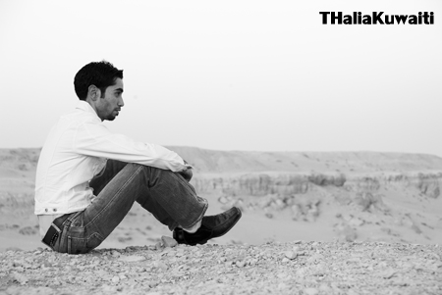  Framing  Framing a picture refers to filling the picture frame with relevant and interesting elements.  Emphasis  Include a focal point of the photograph; call attention to an element.  Different Angle of View  Angle or alter point of view for different effects:  - Eye Level  - Low –angle  - High-angle  Balance  Create a sense of weight for the elements within the frame. Then balance the photo accordingly.  Rule of Thirds  The theory is that if you place points of interest in the intersections, your photo becomes more balanced and will enable viewers of the image to interact with it more naturally.  Close-Up  Close-ups can capture details and highlight specific objects.  Tone & Sharpness  Have your subject in focus and blur the extraneous elements to draw viewers to the subject.  Arrangement  Remove objects not essential to the composition, or eliminate them by changing the camera’s perspective.  Depth of Field  - Refers to the portion of the scene in focus  - Can be long or short  - Dependant on aperture  Aperture  - The opening of the lens.  - Controls the amount of light.  - Measured in f-stops or numbers  - Larger F-number – the smaller the aperture  - Smaller F-number – the bigger the aperture.  Background Distractions  Use simple background, unless it is part of the story.  Avoid dark and bright backgrounds.  Ten Tips for Better Pictures | PPT: DIGITAL PHOTOGRAPHY  Slide 2:  Ask questions about digital photography that will spark interest and understanding.  Ask the class their thoughts on what photography means, and ask why it is “writing with light.”  Explain that pictures speak loud. They can give off different meanings that are not intended.  Slide 3:  Explain that the following terms are going to be covered throughout the presentation.  If one masters these concepts, one can make a quality graphic.  Slide 4:  Explain to be successful in the agricultural communication field, digital photography is a tool and skill to know.  You can have them open up any type of article, news report, magazine, etc.  YOU WILL ALWAYS FIND PHOTOGRAPHS  Slide 6:  Explain how digital photography has changed the digital world.  Slide 7-9  Slide 10:  Explain the benefits of using digital photography over traditional ways.  Most of this information students may already now, so you can take a short time on this slide  Slide11-12:  The major thing they need to know is pixels. When selecting a quality photo for news writing, a photograph with more pixels will be better quality.  Slide 13:  This describes the relationship that pixels have with the size a quality photograph can print, and be clear with good resolutions.  Slide 14:  Resolutions and pixels. Explain what the numbers are used for.  Slide 15-16:  These are the terms they use to reflect photo quality and print size.  Slide 17:  Ask????  What format should you use?  What format is the best?  Why are there three formats to use?  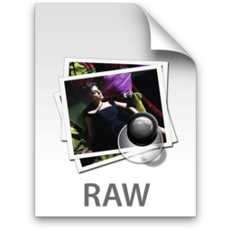  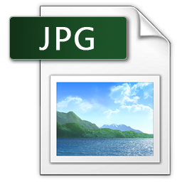  Slide 18:  List why there are three different types and what each is used for, to maximize photo quality with the type of work.  Slide 19-20:  Stress the importance of light.  Break Session:  Have the students use their cell phone cameras or their digital cameras to demonstrate lighting. Break them into groups of two. Have each student take a picture of the other student with the lighting facing his or her back. Next, have them take a picture with the lighting source facing their front. Lastly, have them take a picture with the light source facing off to the side of the other student (left and right). Have them assess each picture and observe the difference. You can download some of the pictures and look at them as a class.  Diagram of Break Session  Pictures:  Slide 21-33:  The following slides are key factors that should be mastered when using digital photography.  Discuss each point in depth as needed.  Share examples. Have them take out their digital cameras and demonstrate each point with the camera as you go.  Lab: Digital Photography  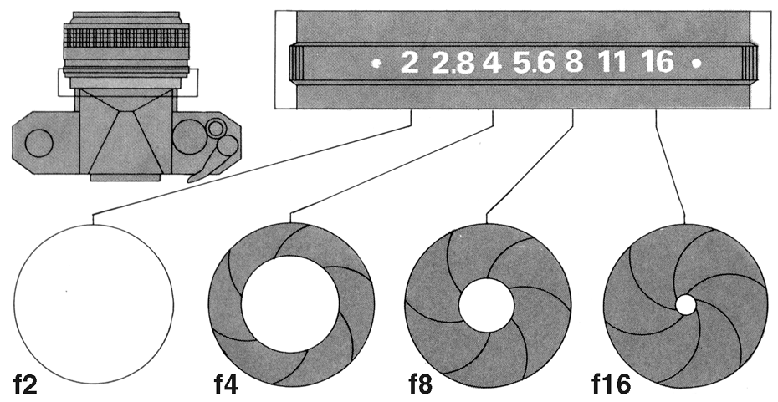  Slides 30- 66 are examples that you can show if desired or share certain photos to better understand the concepts discussed.

Activity:
- Digital Photography Job Sheet
- Practice taking photos with different lights and angles.
Objective C: Select and edit photos for a news story or feature
article.

Objective D: Write an appropriate headline and photo captions for a news story or feature article.

Curriculum (Content)  (What to teach) | Instruction (Methodology)  (How to teach)
What is the purpose of editing photos?  Why do they write captions under photos in article or magazines?  Photographic Editing  Photo Headline and Caption Writing  Photo Editing  - We have learned techniques to take a good photograph.  - The question is. How can you make it better?  - There are various programs you can use, such as  - Photoshop  - Corel Paint Pro  - Photo suite  - And many more  - Throughout this course, we will learn how to use some of these programs.  Basics of Picture Editing  - Grabs viewers attention: For example, in most newspapers, you have less than 3/4 second  - Eye-trac data collection system…typical reader spends ~ 71/100 of a second looking at photos  - Formidable challenge to engage reader  Photo-editing software allows you to  - Alter the hue and saturation of the colors in the photograph  - Smooth surfaces or remove flaws in surfaces  - Remove “red eye”  - Smooth edges and sharpen focus  - Crop and realign photos  - Add special effects  - Change the resolutions  PHOTO EDITING TECHNIQUES  Cropping:  - Permanently cuts off unwanted areas of the photo.  - Focuses on the subject.  - Can be used to ensure correct photo size, balance, etc.  Resolution  - Refers to the number of pixels in an image.  - The higher the pixels per/inch the higher the resolution.  - Remember the higher the resolution the better details but also the larger the file size.  - A good photo resolution is 200-300dpi.  Resampling  - Changes the pixel dimensions by adding or subtracting pixels from original image.  - Enhances the image.  - Makes it smaller, so it is easier to send.  Retouching  - Refers to fixing small areas or “blemishes.”  - Allows to retouch aspects in the photo  - Brightness/Contrast: Light to dark  - Cloning: Copies areas  - Color Adjustment: revise saturation – intensity and richness  - Dodge & burn: light or dark parts of an image  - Drawing tools: provides lines, curves or shapes  - Levels: Adjusts highlights, tones, and shadows.  Photoshop is the number one tool used to edit photos for news and feature stories.  Tools and Techniques:  These tools and techniques will help you edit a photo that will make it even better than its original.  - Navigating Images  - Use Built in Adobe Bridge to browse files.  - Use top tabs when multiple images are open.  - Use selection tool to click on and move image.  - Assessing & Adjusting color  - Often color in images will lack and needs to be enhanced.  - Click > IMAGE > ADJUSTMENTS> HUE & SATURATION to quickly and easily make color adjustments.  - To remove color (create black & white) move saturation value to -100.  - Retouching  - Refers to fixing small areas or “blemishes.”  - Often done to remove acne.  - Can be used to remove power lines, etc.  - Rubber-stamp tool works great to retouch images.  - Selecting  - Use one of the many marquee tools to select a specific area of a photo.  - Cropping  - Permanently cuts off unwanted areas of the photo.  - Can be used to ensure correct photo size, balance, etc.  - Resizing  - It is important to use <SHIFT> key to preserve correct proportions.  - Use sizing handles to adjust size.  - To see sizing handles click “Show Transform Controls.”  - Remember to click arrow and then “Apply” transformation after resizing.  - Resolution  - Refers to the number of pixels in an image.  - The higher the pixels per/inch the higher the resolution.  - Remember the higher the resolution the better details but also the larger the file size.  - A good photo resolution is 200-300dpi  - Experimenting  - Combining Images  - Transforming photos  - By adjusting colors, sizes and filters, you can create nice looking original works of art.  PHOTO CAPTION:  Have you ever looked at a photo and wondered what was going on?  Have you ever been confused by a photo?  Many times pictures do not fully explain its true meaning. To help clarify or add to the story, captions are created under and above the photo.  Captions are the most widely read part of article in a magazine or newsletter. However, it is also the most misunderstood part of news writing.  Behavior or Readers:  A sight in the readers mind  - When writing a cutline with or without a caption, it is useful to have clearly in mind the typical reader behavior when “using” a photograph and accompanying text:  - First, the reader looks at the photo, mentally capturing all or most of the most obvious visual information available.  - When that look at the photo sparks any interest that is when captions must perform.  Photo Captions:  - It provides written information underneath a photograph that is necessary for the reader to understand.  - Who is that? (And, in most cases, identify people from left to right unless the action in the photograph demands otherwise.)  - Why is this picture in the paper?  - What's going on?  - When and where was this?  - Why does he/she/it/they look that way?  - How did this occur?  Captions should explain the picture!  - They should be concise but not sound like a telegram.  - There are certain rules that are followed when using captions.  - Caption:  - Don’t point out the obvious  - Left Indentation  - One to two sentences  - Reflect the image  WRITING CAPTIONS:  - Credit  - Accuracy  - People  - Time  - Information  - Obvious  - Names  - Succinct  - Credit  Photos can be cropped, and the color can be adjusted. Any adjustments beyond that would be considered manipulation of the photo. If the photo is manipulated, in the credit section, you should label the photo as an illustration.  - Accuracy  Reflects the credibility of the product. Everything in the caption should be triple checked.  - People  Triple-check the spelling of names; check with primary sources.  - Time  In captions, use the present tense; write in a conversational tone.  - Information  The caption should include all of the information the reader would want to know.  - Obvious  Don’t repeat the obvious; what’s in the  headline or text of the story.  The use of quotes can be used in captions.  - Names  Triple check names AND positions.  Identify people from left to right.  - Succinct  Use adjectives sparingly; do not say what the person is thinking.  Caption Writing Assignment | PPT: Photographic Editing  PPT: Photoshop Tools & Techniques  PPT: Graphics Editing – Intro to Photoshop  Lessons: Photoshop Introduction & techniques  Lesson: Photoshop – To do List  Lesson: Photoshop Tip and Tricks  Supplemental:  - Photoshop Labs with Video  - Media Photo & 2  Slide 2:  Slide 3:  Slide 4:  Slide 5-7:  These are the basic techniques to enhance photos. However, there is much more.  To help with editing photos, read the Photoshop PowerPoint and Lesson plans.  Photo Job Sheet  Editing Photos in Photoshop  Media Photo Folders  Use the Photoshop – To Do List with the media photos. They all are high-resolution photos.  PPT: Photoshop Tools & Techniques  PPT: Graphics Editing – Intro to Photoshop  To better understand Photoshop, read the lessons listed above on Photoshop. The lessons are basic tips and tricks as well as systematic instruction on all the tools and techniques.  Use the Photoshop To-Do List.  - The lists are the essentials that are essential in editing a photo.  To practice photo editing, there are three folders.  - Media Photo & Media Photo 2 Folders  - Editing Photos in Photoshop  - Photo shop labs with video  The photos in the folders are high resolution photos that will allow you to teach the “Photoshop - To Do List”  Share the folders with the class, so they can save and practice editing the photos.  Lab: Photo Job Sheet  PPT: Writing Photo Captions  Slide2:  Explain that pictures speak louder than words, as long as there is a caption.  Photo Caption Lab  Caption Writing Lab  Slide 4:  Slide 5-6:  Go through with the class- Who, what, where, why, and how of writing a caption.  Rules of caption writing  Slides: 7-16:  Tips and Ideas for writing captions.  Slides 18-37:  Print off Caption Writing Lab  Use the pictures on these slides for the assignment.  Also handout the caption writing guide found in the supplemental folder.

Activity:
- Photo captions lab
- Caption Writing Lab
- Photo Job sheet 1
- Media Photo & Media Photo 2
- Editing photos in Photoshop

Objective E: Write and design the layout of a news story with photos for an agricultural newspaper.

Objective F: Write and design the layout of a feature article with photos for an agricultural magazine.

Curriculum (Content)  (What to teach) | Instruction (Methodology)  (How to teach)
Document Design: Write and Design a Layout with photos.  This is a culmination of all the lessons taught. For Objectives E & F, the students will design their own newsletter. You can combine the class work and create your owns newsletters or magazine.  You will use Photoshop or editing software of choice.  You will use InDesign or Publisher to design the newsletter or magazine.  Use the Graphic Design Lab Folders. This time incorporate the articles, where they write their own piece and use pull text.  After they master it, use the Document Design Lab. The intentions are the class to complete these objectives more than once, so they can master and create a promotional piece for your school, class, and community.  The Graphic Design Labs are the steps that the students will need to take. The only difference in the Document Design lab is that students have to write their own article using journalistic writing. They will have to find or take their own pictures, and design the layout that is desired.  Introduction:  - Getting people to understand your written message is more than just putting words on paper. The message also has to look appealing.  - When you read training manuals or advertisements, you see some type of visual, such as photographs or graphics.  Newsletters:  - Collection of stories  - Easy way to keep members informed  - Sent on a regular basis  NEWSLETER:  - When looking at other newsletters consider the following:  - How big the headlines are  - How easy is it to read  - How crowed the pages appear  - How colorful the newsletter is  - How photographs and graphics are used  NEWSLETTER DESIGN:  - Tips  - Write to be read quickly  - 100-600 words  - 4 page contains around 2,000 words  - Write accurate information  - People like recognition  - Put the best stories first  - Use bigger heading and visual elements for inside stories  - Use document design principles  - Text:  - 10 pt for Normal Text  - 18 + for Headlines  - Color  - Graphics  - White space  - Visual  - Balance  NEWSLETTERS- TYPES  - Newsletters come in many styles and forms. They can have both a formal and an informal tone.  - They fall into three categories  - Bullet Sheet  - One page: front & back  - Newsletter  - 4 – 8 pages  - Short articles  - Mega letter  - Magazine 8-16 pages  - Longer articles  Document Design  - The process of choosing how to present all document elements, so your message is clear and effective.  - When a document is well designed, readers understand the information more quickly and easily.  Key Terms:  The following is a brief overview of the principles of design. Although they are discussed separately, they are really interconnected. Rarely will you use only one principle at a time.  Unity (alignment): The control of variety  Nothing should be placed on the page arbitrarily. Every element should have some consciously designed visual connection with another element on the page. This creates a clean, fresh, and intentional look.  - Necessary to create visual interest balancing visual contrasts combining unusual elements  Order: the hierarchy and dominance of information presented, as well as the emphasis on the elements being defined.  Balance: Is the act of comparing or estimating two  things: one against the other, and the  contrast between  - Empty space (white space) and filled space  - Text and images  - Color and no colors and different colors  - Textures against flat colors  Symmetrical Balance: elements appear to be a mirror image  Asymmetrical Balance: the art of creating balance using uneven numbers, sizes, or kinds of elements  Line: The moving path of a point  Texture: refers to the quality and characteristic of a surface  Pattern: a decorative design  Color: Color can help create emphasis. Without the addition of color, the advertisement could be easily ignored and would be boring to look at.  - Heightens the emotional and psychological dimensions of any visual image  Typography: Can function as shape, texture, point, and line  Word forms must communicate a verbal message as well as function effectively as graphic elements  Shape: a figure or form  Space: an area activated by other elements  Proportion: Relationship to size  Size: the physical dimensions of an element or format  Scale: size comparisons used to create variety and emphasis in a design and help establish visual hierarchy  Rhythm: the choreography of graphic design  Movement: the resulting choreography from rhythm  Contrast: Used to create an interest on the page and to aid in the organization of information  - Can be used typeface, thickness, colors, shapes, sizes and space  Proximity: the position and space given to the placement of elements  Repetition: follows a regular pattern  Process:  Steps:  - Consider the purpose  - Help determine the content and design  - Determine your audience  - What are your readers’ characteristics?  - Match document to audience characteristics  - Young, old, and educated  - Develop a content outline  - Includes main topics  - Helps with the length  - Write the content  - Fliers are short  - Newsletters are long  - Design the document  - Create a sketch – Thumbnail  - Helps with the layout and designing process  - Print the document  - Save in PDF Print  - Professional printing  Getting Started – Document Design  - Putting your thoughts together may be difficult, but the following tips will help with the process  - Learn from good examples  - Look at magazines, brochures, advertisements  - Study for effective designs  - Keep it simple  - Usually the best for design  - Design should enhance the message  - Not to be complicated  - Select appropriate visuals  - Must support the text  - Needs to clarify your message  - High resolution  - Lay out the document  - Fun part  - Piecing it all together  - Follow principles of design  - Balance, alignment, proportion, order, contrast, similarity, unity, proximity and repetition  Document Design:  Visual Elements of a Page  - White space  - Use white space to set off important or “different” items:  - figures and tables (including titles)  - titles  - headings and (some) subheadings  - Follow conventions for margins and line spacing.  - Headings and titles  - Indicate level of heading (major heading, subheading, etc.).  - Be consistent with design of each level  - Consider making differences more prominent than you might at first think.  - Use size and position to differentiate  - Use numbering to differentiate  - Text  - Can be boldfaced, italicized, or underlined.  - Should be used to draw readers’ attention.  - Italicized: quotes, short phrases  - Use serif type and sans serif type for story text  - Bullets  - Use for lists within paragraphs.  - Use bullets carefully – don’t overuse.  - Use when all elements in list are equally important and have no special rank, sequence, or significance.  - Consider using when listed items are long (more than one line) but are not prioritized.  Tips and Style Checklist:  - Use same design for all pages that contain same kinds of information.  - Use limited variety of easy-to-read typefaces.  - Ragged right margin is slightly easier to read for long documents than are fully justified margins.  - ALL CAPS ARE HARD TO READ -- USE SPARINGLY. | PPT: Document Design  PPT: How to Use InDesign  PPT: Introduction to publisher – visual communication.  Lesson: InDesign Tip and Tricks  Lesson: InDesign Manual  Lesson: Introduction to InDesign  Lesson: Intro to Adobe InDesign  Lesson: Indesignintro  Lesson: Introduction to Publisher  Supplemental:  - InDesign Shortcuts  - Newsletter – Word  - Newsletter - Pub  - April-May Newsletter  - March-April Magazine  PPT: Photographic Editing  PPT: Photoshop Tools & Techniques  PPT: Graphics Editing – Intro to Photoshop  Lessons: Photoshop Introduction & techniques  Lesson: Photoshop – To do List  Lesson: Photoshop Tip and Tricks  Slide 2:  Explaining the importance of a quality visual layout with photos.  Slide 3:  Pass out some old newsletters or magazine articles. If you don’t have any, print off some articles that they can read.  Slide 4:  Have them answer the following questions  - How big the headlines are  - How easy is it to read  - How crowed the pages appear  - How colorful the newsletter is  - How photographs and graphics are used  Slide 5-6:  Farm Bureau, Edible Wasatch, Agriscience Research, Rural Cooperative are a few magazines that the students can look at.  Slide 7-8:  Print off or show them examples of the various types. Attached in the supplemental folder are newsletters and a mega letter. They are single, double column newsletter styles.  Next, have them create a newsletter. You can use InDesign or Publisher.  This is a great way to expose your program. You can make this a monthly or bi-monthly project. They can then research and write articles on ag topics that focus on the community and state.  You can go to  www.robertsonclass.weebly.com  - Ag Courses, Lehi Ag Journal  They are examples that I have done to expose our chapter.  Attached also is a publisher example that American Fork FFA uses to promote their program.  First – News Article Review  Second – Newsletter Job Sheet  Slide 10:  Slide 11-29:  These slides explain more about the key terms.  Slides 30-31:  Explain the steps in creating a quality visual document. The steps should be covered, so the students are clear on their expectations.  Print off samples and look at the samples as you discuss the steps.  Slides 32-33:  Pass out magazines that they can look at.  Have them look at four articles and write down on paper what they liked about the layout.  What makes it simple, if so?  Are the visual appropriate? Why?  What did you like about the layout.  This will show that you can learn from examples to improve and enhance the style.  Slide 34-40:  Discuss each element, so they can understand. They can look at magazines and pick out the elements.  Slide 41-42:  When finished, complete the activities.

Activity:
- News Letter – Publisher
- Newsletter Job Sheet
- Graphic Design Lab Folder
- Document Design Lab

Objective G: Design and lay out a brochure.

Curriculum (Content)  (What to teach) | Instruction (Methodology)  (How to teach)
Brochures Document Design  Brochures:  - Are documents used to inform, educate or persuade.  - Attract attention with eye catching design.  - Must be clear, concise, and focused.  - Commonly used to promote organizations, products or events.  BROCHURES:  - Brochures come in many styles and forms.  - Two-fold  - Three-fold (most common)  - Four-fold and more  - Tips:  - Use strong headings  - Speak directly to the reader  - Use bullets to list information  - Keep text short  - Use document design principles  BROCHURE DESIGN:  - Panel 1: The Cover  - Includes: Name, Theme, and a Slogan.  - “Hook” or “Eye Catcher”  - Include attention grabbing text  - Text located at top of panel  - Panel 2: The Message  - Summary of content and message  - Self-contained (content does not carry over)  - Panel 3-5: Main Message  - Viewed as one three-column units  - Contain subheading to break up text  - Panel 6: Back Cover  - Least read section  - Includes contact information  - Email, address, phone number, website, etc.  - Simple design | PPT: Brochures  Lesson: Make a Brochure  Lesson: Print Shop Brochure Instruction  Supplemental:  - Brochure example  - Hunting Brochure example 1-2  To better understand brochures, newsletters and publisher, read the lessons listed above. The lessons are basic tips and tricks as well as systematic instruction on all the tools and techniques.  Slide 2:  Handout some examples as you talk about brochures.  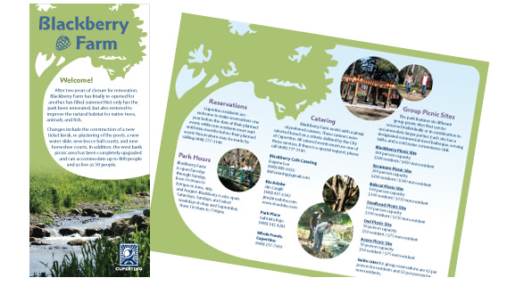  Show some examples from the folders  Slide 3:  Slide 4:  Have the students pull out a piece of paper and draw two lines, dividing the paper into thirds on both sides – landscape style.  As you talk about brochure design, have them write the information on each part of the panels. They can use this when they make their design.  Slide 5:  Explain the layout of a brochure.  When they make their brochure, do not allow them to use templates. They are not always accurate for its purpose.  Next, have them create a brochure.  Use the Brochure Job Sheet  Remember to put the paper in the right way, so the brochure is printed correctly on both sides. The brochure can also be made in InDesign if you want.

Activity:
- Brochure Job Sheet

Evaluation:

Photography & Print Media Exam

Job Sheets (quality and scores)

References:

- Telg, R. & Irani, T. (2012). Agricultural communications in action: a hands-on approach. Delmar, Cengage Learning, Clifton Park, NY.
- American Fork High, Jake Anderson
- Lehi High Photo Teacher – Chris Greismer
- Utah State University Ag Communications Program
- USU extension & experiment stations.

Meets USOE Standards and Objectives:

