PLANT ANATOMY, GROWTH AND DEVELOPMENT

LABORATORY EXERCISE #10--PLANT GROWTH

Name________________________________________ Score______________________________

Selection from Modern Biology, Biology Investigations, Teacher's Edition, by James H. Otto, Albert Towle, W. David Otto, and Myra E. Madnick. Copyright 1977 by Holt, Rinehart and Winston, Inc. Reprinted by permission of the publisher.

Materials needed

1 vigorously growing bean plant in an individual container
3 Bean Seeds
3 Corn Seeds
1 Glass Jar
Paper Towels or newspaper
Metric ruler (divided into millimeters)
Thread
India ink

Part I: Observing Vegetative Organs

Grow Bean and Corn Seeds in Glass Jar, Fill glass jar with paper towels or newspaper. Put seeds in between glass and paper towels and moisten towels. Then watch seeds grow, students will observe difference between monoct and Dicot, stems, roots, leaves.. You are now able to observe all of the vegetative organs of a seed plant.

a. What parts of the plant can you observe?

b. What does it mean for an organ to be vegetative?

c. Examine the root system closely, and describe what you see.______________________________

d. What characteristic may be observed which indicates the anchoring function of the roots in the

soil?

e. What are some other functions of roots?

Examine the stem.

f. What obvious plant organ is attached to the stem?

g. On the basis of your answer to (f), what is one of the functions of the stem?

h. What color is the stem?

i. What pigment is present?

j. Name another function that may be carried out in the stem.

k. How do water and minerals get to the leaves from the roots?

l. How do materials move from the leaves to the roots?

m. On the basis of your answers in (k) and (l), what function is being performed?

___________________________________ Like the root, the stem often functions in the

storage of food. Examine the leaves.

n. What color are they?

o. What is the principal function of the leaves?

In the space provided, sketch the entire plant. Include the details of the branching pattern of the roots, and the shape and venation of the leaves. Label: roots, stem and leaf. Summarize the functions of each vegetative organ.

Part II: How Fast Do Plant Parts Grow?

Plant a bean seed in a pot containing equal parts of sand and loam. Plant it just below the soil surface. Water the soil well and pour off the excess. Place the pot in a light source and keep the soil moist. Once the true leaves of the plant are formed, your observations and determination of the rate of growth may begin.

To observe where the leaf expands in its growth, mark a small leaf in the following manner: Draw a piece of thread (15-20 cm) tightly between the forefinger and thumb of each hand. Have your partner moisten the thread with the applicator from an India ink bottle. Carefully place the moistened thread on the leaf to make a straight line across the leaf. Repeat the procedure and make the next line approximately 3 mm from the first. Continue until the leaf is marked as shown in the figure below. In the same manner, mark the stem from the soil surface to the tip of the stem.

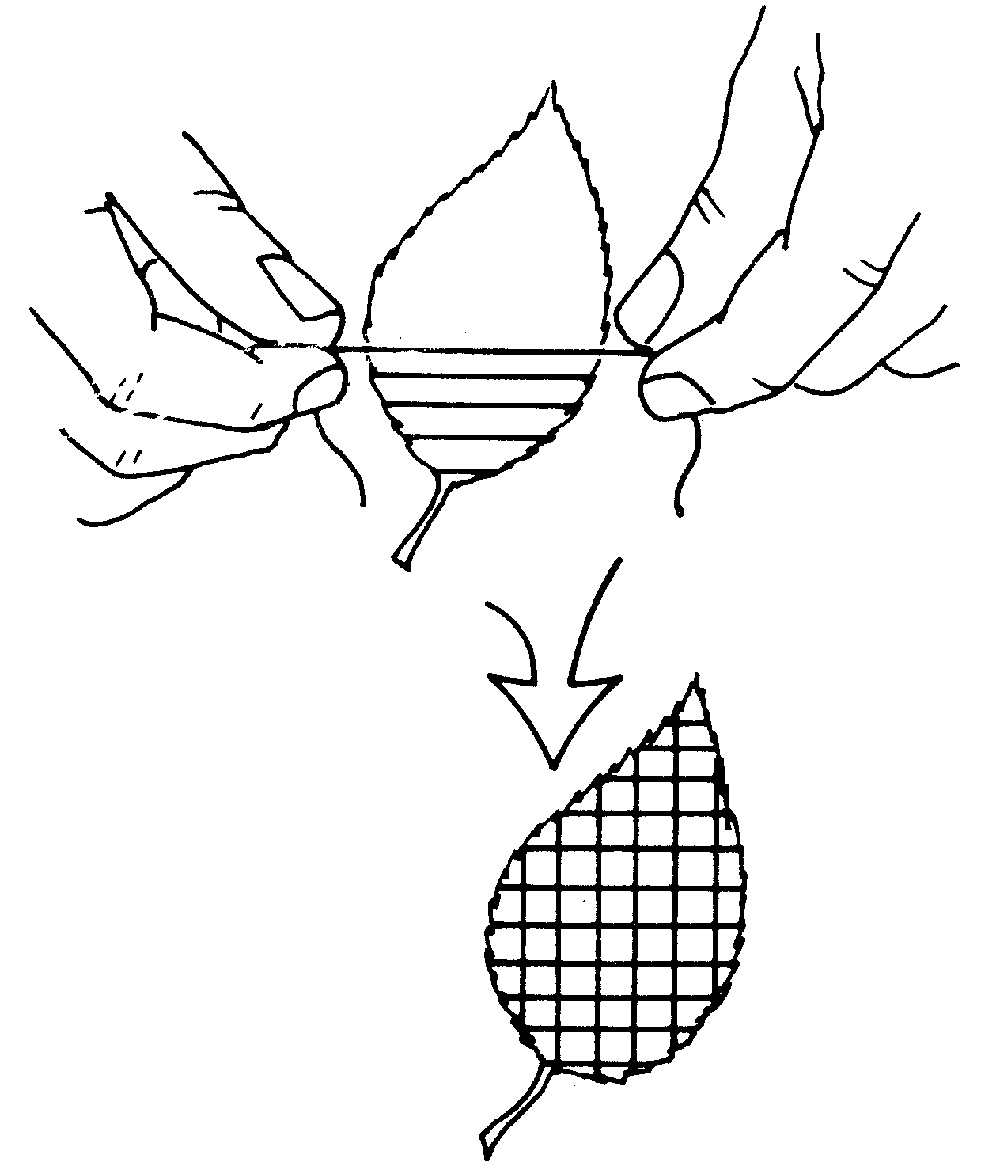

a. What will the markings help you to observe?

As the leaf expands, record your observations in a series of drawings by accurately representing the regions of expansion.
b. How will you be able to determine where the leaf and stem grew?

Use a metric ruler to obtain actual growth measurements. Measure in millimeters the length of the stem from the soil level to the growing tip. Record the measurement in the table below.

Count and record the number of leaves. Determine the surface area of each leaf by multiplying the length of the leaf (base to tip) by the average width (measure in three places) of the blade. Record the total surface area of all leaves. Repeat the measurement at 2-3 day intervals for a period of two weeks. Record all data in the table.

After the last measurements are recorded, carefully remove the plant from the soil. Wash the soil from the roots. Measure each root and record the total length of the root system.

Base your answers on the markings and the measurements taken.

c. Was the rate of growth uniform in the stems and leaves during the growth period?

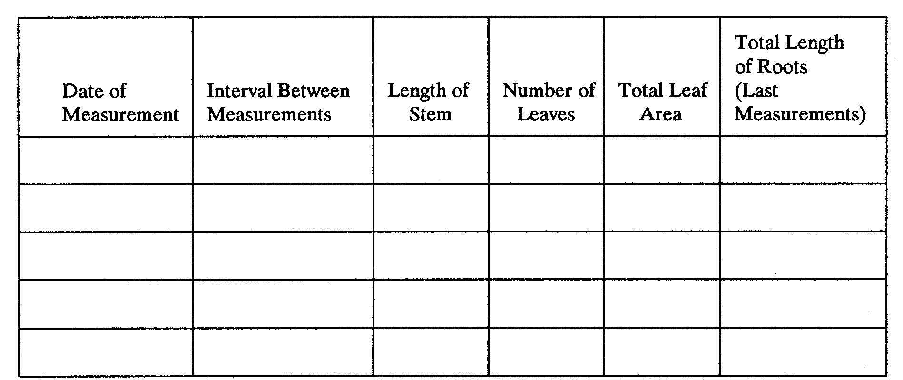

d. If not, when is the rate of growth most rapid?

e. Compare the total length of the stem with that of the root.

f. Did the leaf blades continue growth at a uniform rate?

g. If not, what variation occurred?

h. Where were new leaves produced?

i. How does the area of the plant above and below the ground compare?

Part III: Summary

a. Using a suitable scale of numerical value, prepare a graph with separate lines for length of stem, number of leaves and total leaf area. Explain any observable relationship.

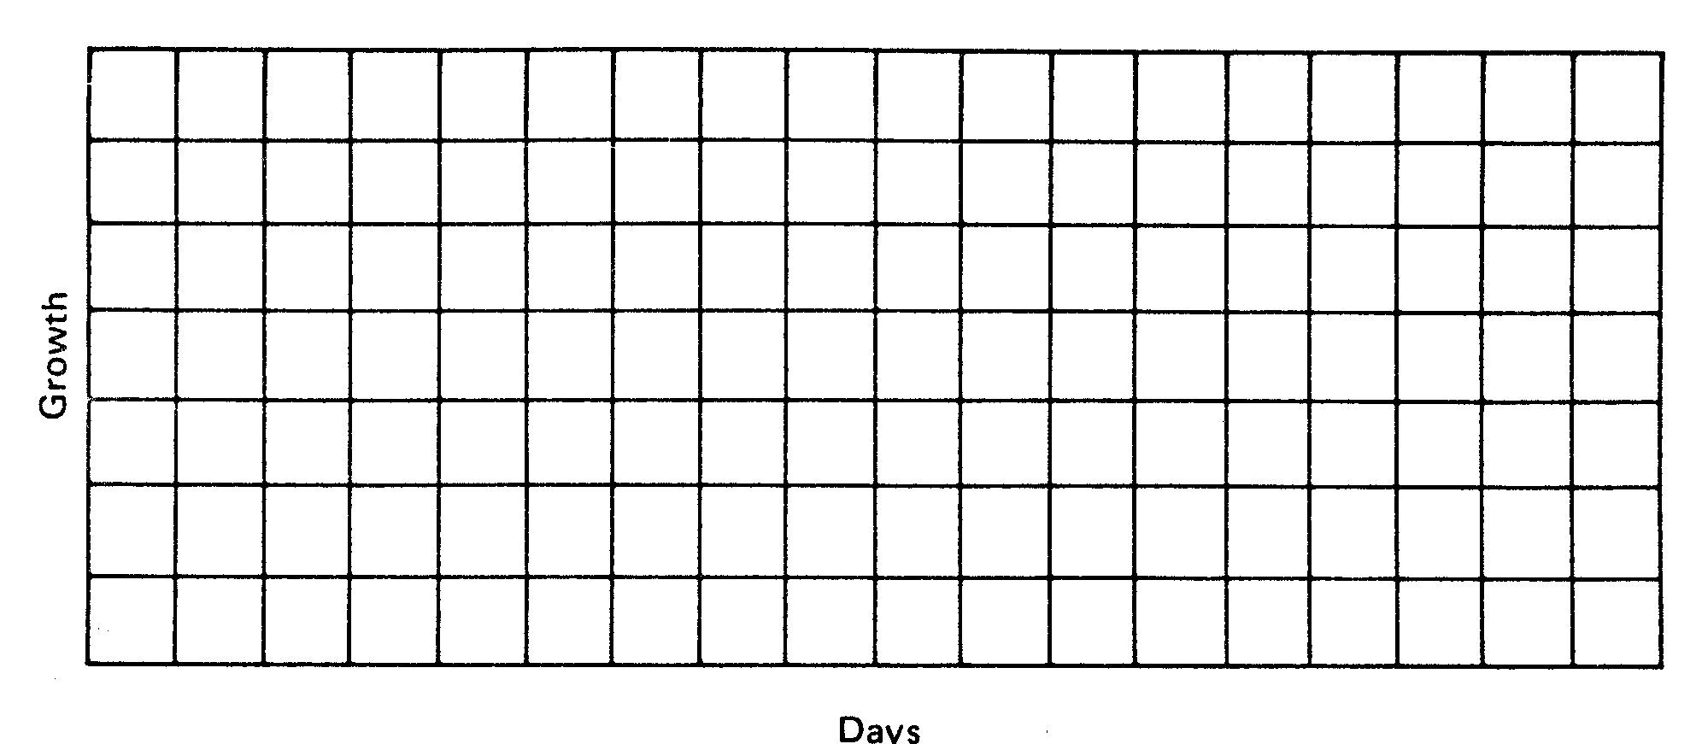

In the space provided, indicate which vegetative organ(s) of the plant perform the function indicated.

b. ____________________________________________ conduct water and minerals to upper

plant parts.

c. ____________________________________________ are the principal organs of

photosynthesis.

d. ____________________________________________ serve to anchor the plant.

e. ____________________________________________ produce leaves.

f. ____________________________________________ store food substances.

g. ____________________________________________ exchange gases between the plant and the

atmosphere.

h. _____________________________________________ absorb water and minerals.
i. _____________________________________________ have a secondary function of

photosynthesis.

j. _____________________________________________ conduct water and minerals up and

down the plant.

k. _____________________________________________ display leaves to light.

l. _____________________________________________ function in the process of transpiration.

Part IV: Investigations On Your Own

Select various growth media such as sand, vermiculite, heavy clay soil, etc. Observe how the type of soil influences seedling growth. The procedure as presented in Part 2 should be followed. To observe the effects of soil nutrients, you may wish to use laboratory prepared nutrient solutions or those prepared commercially in addition to selected soil types.

Answers to Lab #10

Lab #10

Part I:

a. Roots, stems and leaves
b. A vegetative organ performs all the processes necessary for life except the formation of seeds.
c. The root system is highly branched and is lacking any color.
d. The root system is highly branched and spreading.
e. Absorption of water and minerals, conduction of water and minerals to other plant parts, food storage
f. Leaves
g. Produce and display leaves to light
h. Green
i. Chlorophyll
j. Photosynthesis
k. They are carried in the stem.
l. They are carried in the stem.
m. Conduction
n. Green
o. Photosynthesis

Part II:

a. Where growth occurs in the leaves and stem

b. The squares on the leaf will change shape indicating that growth has occurred. The markings on the stem will become further apart indicating growth has taken place in that region of the stem.

c. No

Answers will vary on the chart

d. Growth should proceed more rapidly during the first half of the growth period and then slow down.

e. Answers will vary

f. No

g. The squares formed by the lines on the leaf have changed shape. This indicates that the leaf grew more from the center regions of the leaf.

h. At the sides of the shoot apex

i. The area is approximately the same.

Part III:

a. Generally, the three curves will follow the same pattern. As the stem length increases, more leaves are produced and the total surface area of the leaves will also increase.
b. Roots
c. Leaves
d. Roots
e. Stems
f. Roots and stems
g. Leaves
h. Roots
i. Stems
j. Stems
k. Stems
l. Leaves

