Punctuation Packet Page # 1

Name _________________________________ Date__________

1. What is the definition of a verb?
2. List five common “be” verbs

*Instructions: Locate the verbs in the following sentences and mark above them the number 3.*

1. Monsanto has been quite successful in convincing farmers that GM crops are the ticket to greater yields and higher profits.
2. You still hear that rhetoric at the United States Department of Agriculture.

1. A 2006 USDA report could not find positive financial impacts for adopting Roundup Ready soybeans.
2. The biggest issue raised by these results is determining how to explain the rapid adoption of [GM] crops.
3. The average GM crop from Monsanto reduces yield.

1. This was confirmed by the most comprehensive evaluation on the subject.
2. U.S. farmers had expected higher yields with Roundup Ready soybeans.
3. Independent studies confirm a yield loss of 4 to 11 percent.
4. Brazilian soybean yields are also down since Roundup Ready varieties were introduced.

Punctuation Packet Page # 2

Name _________________________________ Date__________

1. What is the definition of a noun?
2. What is a subject?
3. What question can be asked to identify the subject?

*Instructions: Identify the verbs in the following sentences by placing the number 3 above them, mark the nouns with the number 1 above them, and circle the subject.*

1. Wisconsin ranks second among states as a dairy producer.
2. Wilma was crowned the Dairy Queen of the local FFA Sweetheart pageant.
3. As a result of hard work, Wilma is the FFA star Greenhand and a proficiency award recipient.
4. I am late for work because I followed an International Harvester half-way here.
5. Billy strives to meet high personal standards, an admirable aspiration.
6. Soft white wheat is commonly used in cereals.
7. Garlic is known as the stinking rose and is produced in large amounts in Washington state.
8. George Washington, a national leader, was also a farmer and one of the first to breed mules in the United States.

Prepositions Punctuation Page # 3

Name _________________________________ Date__________

A preposition relates nouns to other words in a sentence, like showing time, direction, position, and comparison; and is all the things a worm can do to an apple, not including verbs. Like a worm can go “through” an apple.

*Instructions: Draw an example of fifteen prepositions. List twenty at the bottom of the page.*

List:

Punctuation Packet Page # 4

Name _________________________________ Date__________

1. Describe the difference between an adverb and adjective.
2. Give four examples of a conjunction.

*Instructions: Label the words in the following sentences as verb=3, noun =1, 2=determiner, 4=adjective, 5=adverb, 6=pronoun, 7= conjunction, 8=preposition, 9=noun directly following preposition, 10=interjection.*

1. The pony, the light horse, and the draft horse are three types of domestic horses.
2. They examined each apple carefully before they used it.
3. The orchard owners made apple cider and apple sauce.
4. The trees died when they caught the fungal disease.
5. Johnny Appleseed is a legendary apple grower.
6. Some contemporary art stirs controversy.
7. Many people find the art of wine-making interesting.
8. Vineyards around the world produce grapes for wine.
9. The olive is a staple in Italian cuisine; it can be used as a whole fruit or for oil.
10. Many ancient civilizations declined because of erosion.
11. Floods along river banks can be a good thing as they bring new top soils.
12. Home cooked meals are unique as the eater knows all of the ingredients.

Verbals and Punctuation Page# 6

Name _________________________________ Date__________

C:\Users\Jacie\AppData\Local\Microsoft\Windows\Temporary Internet Files\Content.IE5\QKVU0UMM\MC900417460[1].wmfP I G

Why are we learning about verbals?

Write two examples each of a participle, infinitive and gerund.

Verbal Practice Page # 7

Identify the verbal phrases in the following sentences by underlining them, then classify as a P, I or G. Use our numbering system to identify the parts of the speech in the rest of the sentence.

1. The thief arrested for the robbery shot at the security guard.  
     
   2. The flag waving in the wind is inspirational.  
     
     
   3. They are sure the extra planning will make a difference in the end.  
     
     
   4. Jamal's confusing message did nothing to solve the mystery.  
     
     
   5. Godzilla made a game of smashing all of the red cars parked near the lake.  
     
     
   6. The politician's broken promises were all that the voters remembered.  
     
     
   7. Delighted with the opportunity to learn, Christine took the internship in New York.  
     
     
   8. While playing the tuba, Orin felt as if his world was perfect.  
     
     
   9. The show offers everyone a chance to be a millionaire.  
     
   10. Samuel decided that missing the lecture every day was hurting his grade.  
     
     
   11. The kittens crouching under the bed have refused to come out.  
     
   12. The swimmer, driven by the need to be the best in the world, made himself sick with anxiety.



Proofreading Page# 8

Name­­­­­­­__________________________________ Date__________

*Instructions: Using the correct marks, correct the following passages.*

would a company ship hay from Seattle Washington to Tokyo Japan Hay is actually one of Washington State’s largest export commodities [ACX. Trading, Inc.](http://www.acxtrading.com)who is using the Boomerang Box this week is the leading Processor and exporter of high quality custom packaged dairy feed products to asiay

hay is just one type of feed product feed products are just as they sound products used to feed Animals mostly dairy cows beef cattle and horses washington States kittitas Valley is famous for production of Timothy Hay historically, Timothy, was a natural grass grown in the high mountain valleys of europe and later in the highlands of new englande.

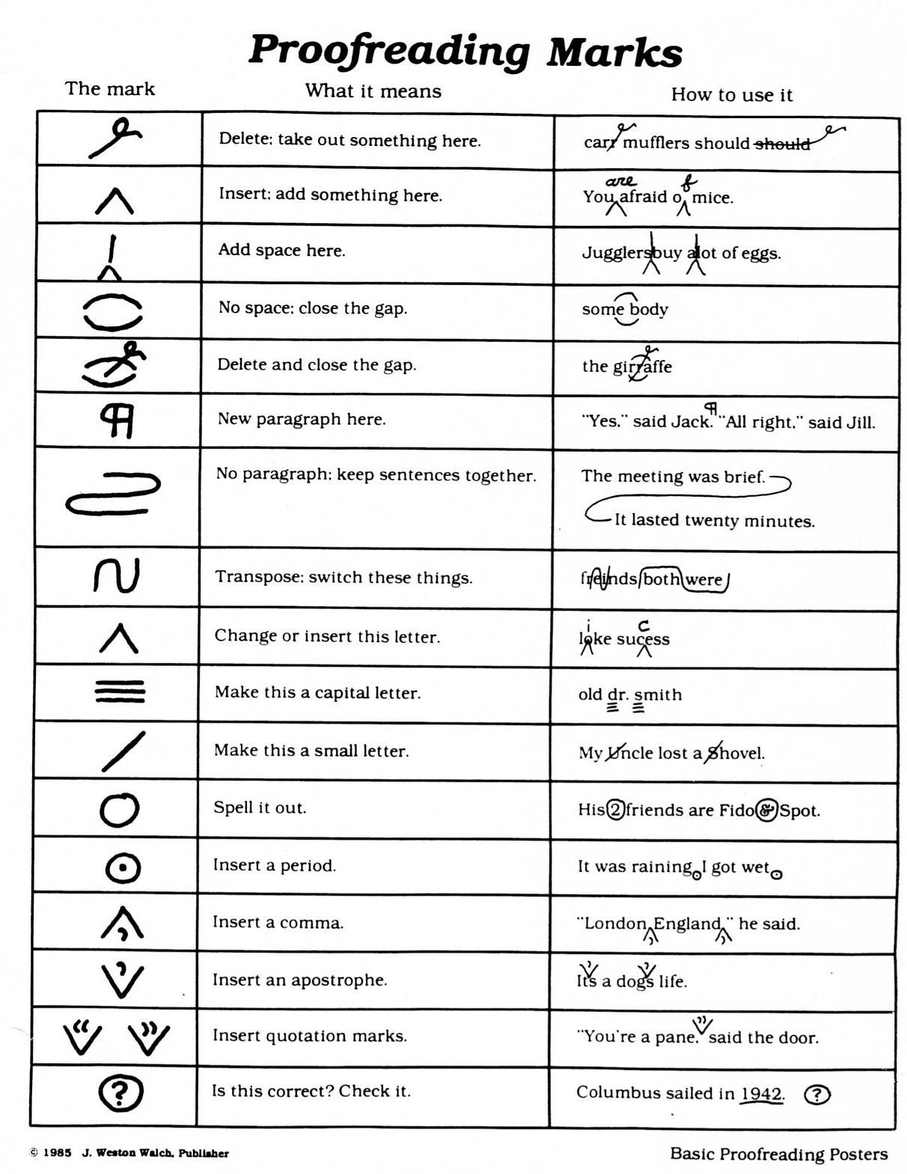

Comma Notes

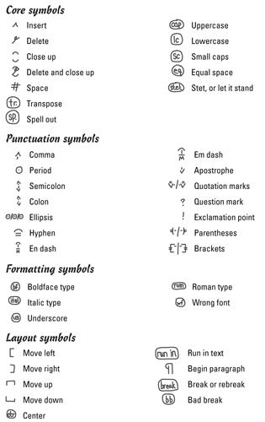

Punctuation Packet

Key and Explanations # 1

Name _________________________________ Date__________

1. What is the definition of a verb?

Shows action or state of being.

1. List five common “be” verbs

Is am was were be being have

*Instructions: Locate the verbs in the following sentences and mark above them the number 3.*

1. Monsanto has been quite successful in convincing farmers that GM crops are the ticket to greater yields and higher profits.
2. You still hear that rhetoric at the United States Department of Agriculture.

1. A 2006 USDA report could not find positive financial impacts for adopting Roundup Ready soybeans.
2. The biggest issue raised by these results is determining how to explain the rapid adoption of [GM] crops.
3. The average GM crop from Monsanto reduces yield.

1. This was confirmed by the most comprehensive evaluation on the subject.
2. U.S. farmers had expected higher yields with Roundup Ready soybeans.
3. Independent studies confirm a yield loss of 4 to 11 percent.
4. Brazilian soybean yields are also down since Roundup Ready varieties were introduced.

Punctuation Packet Page # 2

Name _________________________________ Date__________

1. What is the definition of a noun?

A person, place or thing.

1. What is a subject?

The person, place or thing the sentence is about.

1. What question can be asked to identify the subject?

Who or what verb? – In the below example have the kids identify the verb. Then identify all nouns. Then have them ask the question who or what ranks? – The answer is Wisconsin ranks. Now the student can identify the subject.

*Instructions: Identify the verbs in the following sentences by placing the number 3 above them, mark the nouns with the number 1 above them, and circle the subject.*

*1 3 1 1 1*

1. Wisconsin ranks second among states as a dairy producer.

1 3 3 1 1 1 1 1

1. Wilma was crowned the Dairy Queen of the local FFA Sweetheart pageant.

1 1 1 3 1 1

1. As a result of hard work, Wilma is the FFA star Greenhand and a proficiency award recipient.

1 1 3 1 1 1

1. The International Harvester caused many travelers to be late for work.

1 3 1

1. Soft white wheat is commonly used in cereals.

1 1 1 3 1 1

1. George Washington, a national leader, was also a farmer and one of the first to breed mules in the United States.

Prepositions Punctuation Page # 3

Name _________________________________ Date__________

A preposition relates nouns to other words in a sentence, like showing time, direction, position, and comparison; and is all the things a worm can do to an apple, not including verbs. When a sentence begins with a preposition and the phrase from 8 to 9 has four or more words a comma needs to follow.

A worm can go in the apple. A worm can go around the apple. A worm can go beneath the apple. Etc.



*Instructions: Draw an example of fifteen prepositions. List twenty at the bottom of the page.*

List:

Punctuation Packet Page # 4

Name _________________________________ Date__________

1. Describe the difference between an adverb and adjective.

Adverb describes how many, how much, and to what extent. Adverbs further explain a verb and other adverbs. Sometimes they end in “ly”.

Adjective describes a noun or pronoun. It answers the questions what kind. Like what kind of house? A red house. So red is the adjective.

Adjective adjective should be divided by a comma.

1. Give four examples of a conjunction.

And, but, or, nor When a sentence contains one subject and two verbs then there is no comma at the conjunction. When a sentence contains two subjects and two verbs then a comma is needed at the conjunction.

*Instructions: Label the words in the following sentences as verb=3, noun =1, 2=determiner, 4=adj, 5=adverb, 6=pronoun, 7= conjunction, 8=preposition, 9=noun directly following preposition, 10=interjection.*

*2 1 2 4 1 7 2 1 3 5 1 8 4*

1. The pony, the light horse, and the draft are three types of domestic

9

horses.

6 3 4/5 1 5 8 6 3 9

1. They examined each apple carefully before they used it.

2 1 1 3 4 1 7 4 1

1. The orchard owners made apple cider and apple sauce.

1 1 3 2 4 1 1

1. Johnny Appleseed is a legendary apple grower.
2. 1 3 2 1 8 9 4

9. Many people find the art of wine-making interesting.

2 1 3 2 1 8 4 9 1 3 3 3 8 2 4 1

Verbals and Punctuation Page# 6

Name _________________________________ Date__________

Participle Infinitive Gerund

Participles are phrases that have verb-like words in them.

Why are we learning about verbals?

Because verbals tell us how to punctuate! Participles are followed by a comma or set off by a comma, gerunds are never separated from the verb by a comma.

Write two examples each of a participle, infinitive and gerund.

Participles should be set off by a comma when at the beginning of a sentence.

* Running around the track, the dog entertained people by chasing butterflies.

Infinitives are the word “to” + a verb these do not need to be separated by a comma.

* To feel this good is to be so happy

Gerunds are much like infinitives they take the place of a noun but do NOT need to be separated by a comma.

* Walking in the rain makes me mad

Verbal Practice Page # 7

Identify the verbal phrases in the following sentences by underlining them, then classify as a P, I or G. Use our numbering system to identify the parts of the speech in the rest of the sentence.

1. The thief arrested for the robbery shot at the security guard.  
     
   2. The flag waving in the wind is inspirational.  
     
     
   3. They are sure the extra planning will make a difference in the end.  
     
     
   4. Jamal's confusing message did nothing to solve the mystery.  
     
     
   5. Godzilla made a game of smashing all of the red cars parked near the lake.  
     
     
   6. The politician's broken promises were all that the voters remembered.  
     
     
   7. Delighted with the opportunity to learn, Christine took the internship in New York.  
     
     
   8. While playing the tuba, Orin felt as if his world was perfect.  
     
     
   9. The show offers everyone a chance to be a millionaire.  
     
   10. Samuel decided that missing the lecture every day was hurting his grade.  
     
     
   11. The kittens crouching under the bed have refused to come out.  
     
   12. The swimmer, driven by the need to be the best in the world, made himself sick with anxiety.



Proofreading Page# 8

Name­­­­­­­__________________________________ Date__________

*Instructions: Using the correct marks, correct the following passages.*

would a company ship hay from Seattle Washington to Tokyo Japan Hay is actually one of Washington State’s largest export commodities [ACX. Trading, Inc.](http://www.acxtrading.com)who is using the Boomerang Box this week is the leading Processor and exporter of high quality custom packaged dairy feed products to asiay

hay is just one type of feed product feed products are just as they sound products used to feed Animals mostly dairy cows beef cattle and horses washington States kittitas Valley is famous for production of Timothy Hay historically, Timothy, was a natural grass grown in the high mountain valleys of europe and later in the highlands of new englande.



